Deploying Azure Protected Geo-Redundant Solutions with Path Based Routing

## Project for Cal Tech AZ304 Course

Author: David Hill Jr.

# Business Scenario

The Tyrell Corp wants to build a highly secured Globally distributed application. This application serves two types of content: images and dynamically rendered webpages. As their user base comes from across the globe this must be geographically redundant. The design demands that it should serve its users from the closest (lowest latency) location to them. For distinction, Tyrell Corp has decided that any URLs that match the pattern /images/* are served from a dedicated pool of VMs that are different from the rest of the web farm.

Design the Load Balancing architecture for Tyrell Corp.

For this assignment do it in East US region, then you can select any other region and add those Application gateways on created Traffic manager.

# Overview

The main tasks for this exercise are as follows:

1. Login to Azure Portal
2. Provision Application gateway
3. Add application gateways to the Traffic Manager endpoint

# Architecture

The architecture for the system will be as follows. We will have two VM pools. One to serve static sites and one to serve the images. The load to both of these will be handled by the load balancer. The requests will go to the load balancer from an application gateway with the traffic manager service enabled to ensure that users get routed to the best VM for their location.

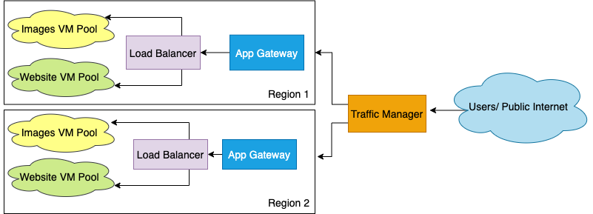

# Method

To create and deploy our Azure resources, we will use an Azure ARM template. This will allow us to create all of our resources at once which will make the process a lot easier.

# Create a Resource Group

The first step is to create a resource group which we can do with the following command in the Azure CLI:

az group create –-name TyrellCorp –-location eastus

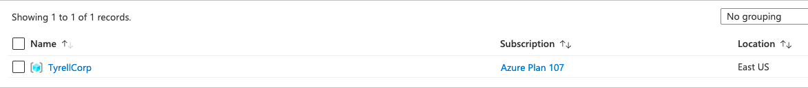

Now that we have a resource group, we now can create our ARM template that will deploy resources to the resource group.

# Website VM’s

# Image VM’s

# Load Balancer

# Application Gateways

# Traffic Manager